WEAK 2 PROJECT MODULE NO 1

FOOTPRINTING & RECONNAISSANCE ATTACKS WITH MULTIPLE KALI TOOLS

CYBERSECURITY & ETHICAL HACKING PROJECT TASKS

Reconnaissance: Reconnaissance is the intelligence-gathering phase of cybersecurity in which security professionals systematically identify and analyze a target's digital attack surface, including IP addresses, domains, subdomains, DNS records, technologies, exposed services, employee information, and potential vulnerabilities. It involves passive and active techniques such as OSINT, DNS enumeration, WHOIS, metadata analysis, and network fingerprinting to discover hidden assets and potential attack vectors. Its primary objective is to build an accurate target profile, identify security weaknesses, and support effective penetration testing and threat assessment.
TASK NO 1: Run whois to find the domain registration details.
WHOIS Tool: WHOIS is a reconnaissance tool used to retrieve publicly available domain registration information. It helps security professionals identify domain owners, registrar details, registration and expiration dates, name servers, and administrative or technical contact information. In cybersecurity, WHOIS is useful for OSINT, identifying domain relationships, investigating suspicious infrastructure, and gathering intelligence during penetration testing.
I use command “whois networkwalks.com” and get following important information. (Screenshots is attached):
The WHOIS lookup reveals that networkwalks.com was registered on 6 November 2019 through GoDaddy.com, LLC, with an expiry date of 6 November 2027. The registrant's identity is protected by Domains By Proxy, LLC, indicating WHOIS privacy protection. The domain uses HostGator and DomainControl name servers, while DNSSEC is unsigned. The domain also has restrictions on deletion, renewal, transfer, and modification (clientDeleteProhibited, clientRenewProhibited, clientTransferProhibited, clientUpdateProhibited).
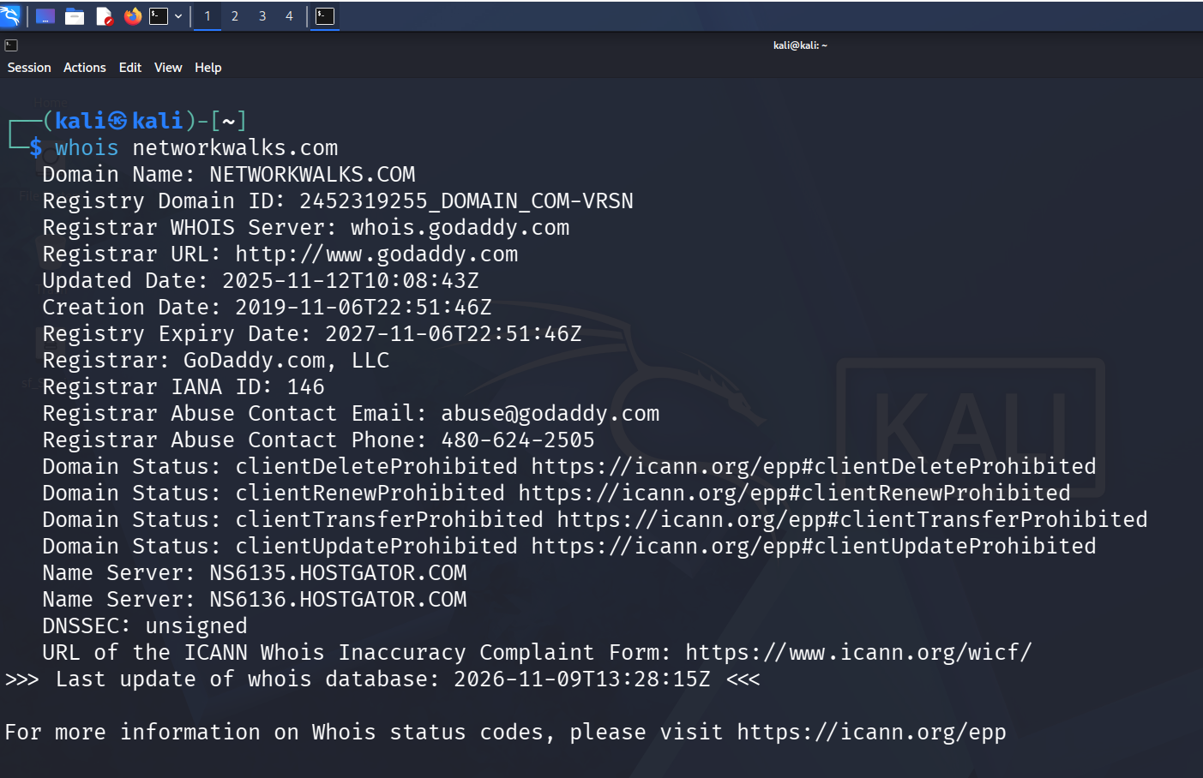
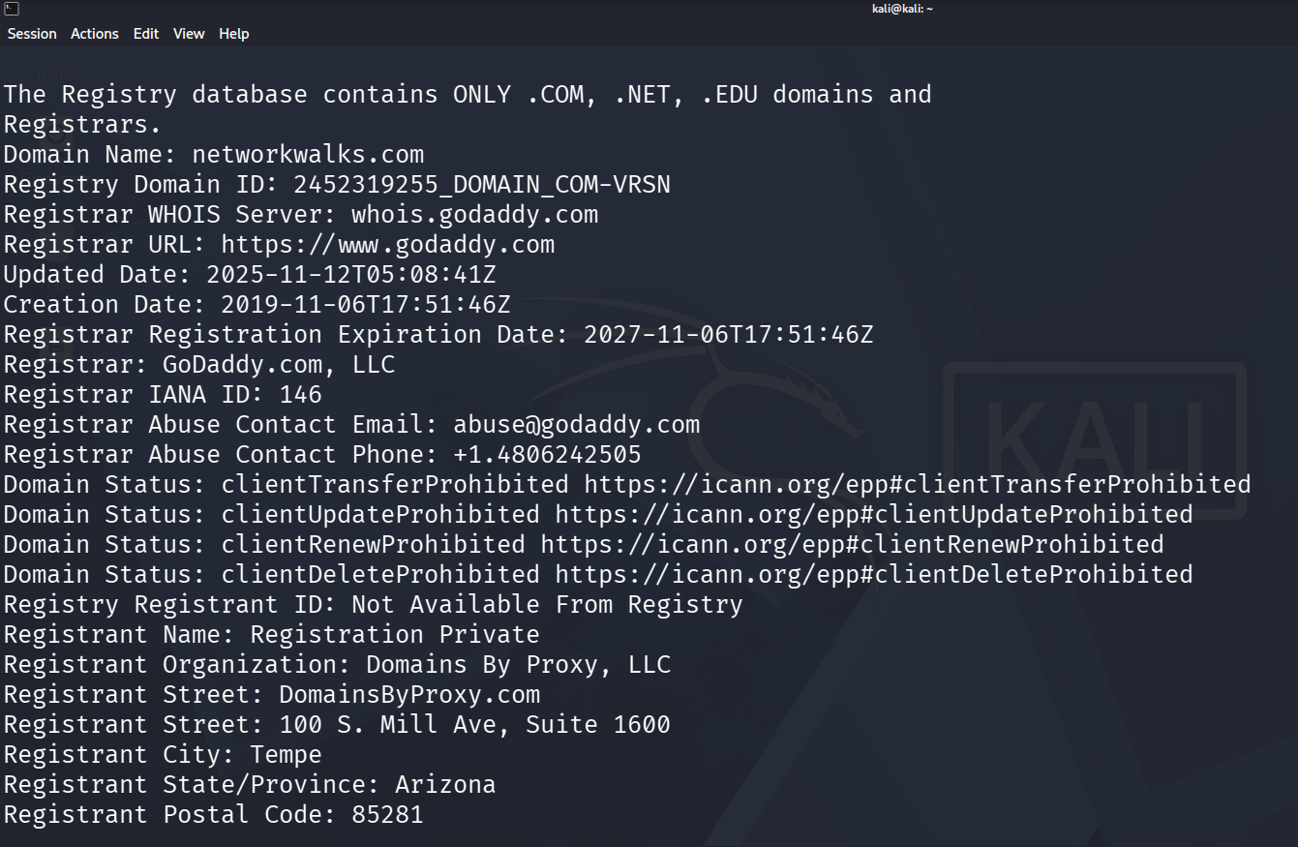
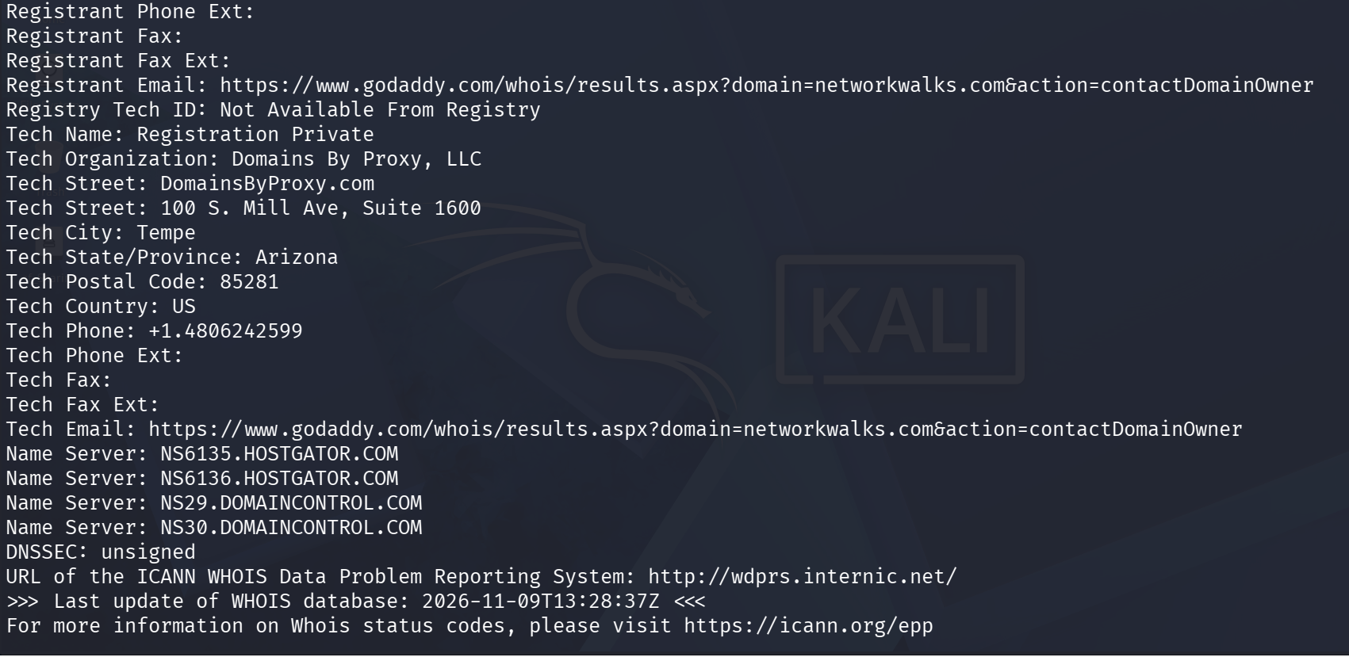

TASK NO 2: Run whatweb to fingerprint the web technologies.
WhatWeb Tool: WhatWeb is a web technology fingerprinting tool used during the reconnaissance phase of penetration testing. Its primary purpose is to identify the technologies running behind a website, including CMS platforms (WordPress, Joomla), web servers (Apache, Nginx), programming frameworks, JavaScript libraries, and technology versions. It analyzes HTTP responses, headers, cookies, and webpage content to build a technical profile of the target. This information helps security professionals identify outdated technologies, potential vulnerabilities, and possible attack vectors
Basic Linux Command is: whatweb networkwalks.com
The WhatWeb scan identifies the target website as Networkwalks Academy, running on WordPress 7.1.4. The web server is Apache, with IP address 192.232.216.135, hosted infrastructure showing US geolocation. The website uses Bootstrap 7.1.4 and jQuery 3.7.1 for frontend functionality, along with WordPress Download Manager 3.3.76. Google Tag Manager is also detected. The website redirects HTTP traffic to HTTPS (301 Moved Permanently), and the HTTPS version responds with 200 OK. Additional findings include the email info@networkwalks.com, an __wpdm_client cookie with HttpOnly protection, and several security-related HTTP headers.
Security Observation: The scan reveals the website's technology stack and exposed information, which can help identify outdated components and potential attack surfaces. However, detected technologies alone do not confirm vulnerabilities.
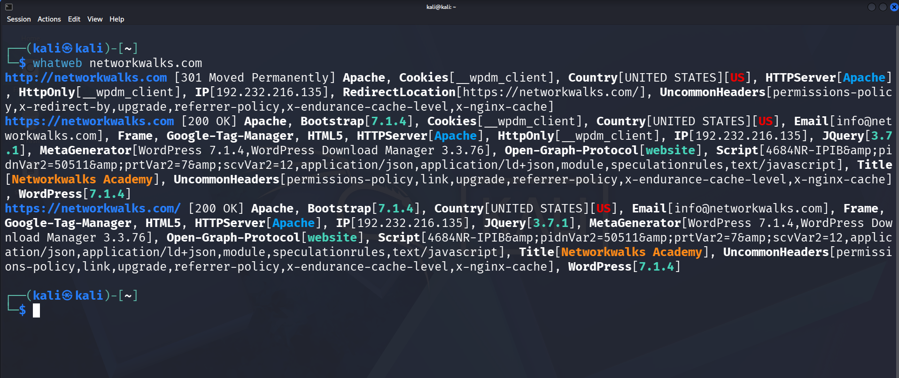

TASK NO 3: Run nslookup to resolve the domain to its IP Address
Nslookup: NSLOOKUP (Name Server Lookup): NSLookup is a command-line network reconnaissance tool used to query DNS (Domain Name System) servers and retrieve information about domain names and IP addresses. It helps security professionals identify DNS records such as A (IPv4), AAAA (IPv6), MX (Mail Exchange), NS (Name Server), TXT, and CNAME records. During reconnaissance, NSLookup is useful for discovering domain infrastructure, identifying mail servers, checking DNS configurations, and understanding how a target domain resolves across the internet.
Basic Linux Commands are:

nslookup networkwalks.com
nslookup -type=MX networkwalks.com
nslookup -type=NS networkwalks.com
nslookup -type=TXT networkwalks.com

Security Purpose: DNS enumeration helps penetration testers map domain infrastructure and identify potentially exposed services or misconfigurations.
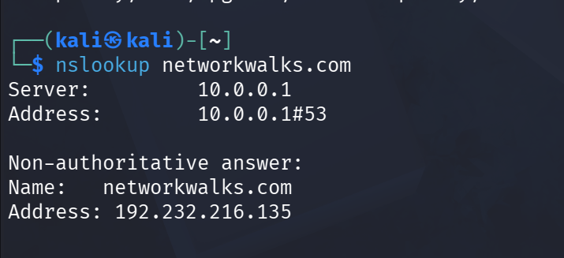

TASK NO 4 : Run curl -I to read the HTTP response headers.
curl (Client URL): cURL is a command-line tool used to transfer data between a client and server using protocols such as HTTP and HTTPS. In cybersecurity reconnaissance, it helps security professionals inspect HTTP response headers, server information, cookies, redirects, and website responses. It is particularly useful for analyzing web server behavior, troubleshooting HTTP communication, and identifying exposed information without using a browser
Basic Linux Commad is:
curl -I https://networkwalks.com
curl Scan – Key Findings for networkwalks.com:
The curl header inspection shows that the website responds with HTTP/2 200 OK, indicating successful communication over HTTPS. The web server is Apache, and the response identifies WordPress infrastructure through the /wp-json/ REST API endpoint. The website sets a __wpdm_client cookie with Secure and HttpOnly attributes, helping protect cookie transmission and client-side access. Additional security-related headers include Permissions-Policy and Referrer-Policy. The response also reveals Nginx caching integration and HTML content served with UTF-8 encoding.
Security Observation: The exposed WordPress REST API endpoint and HTTP response headers provide useful reconnaissance information about the website's architecture and technologies. Their presence alone does not indicate a security vulnerability.
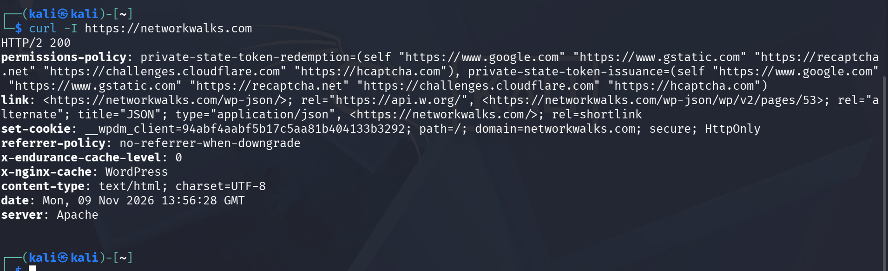

TASK NO 5: Run wafw00f to detect a Web Application Firewall.
WAFW00F Tool: WAFW00F is a web application firewall (WAF) fingerprinting tool used during the reconnaissance phase of penetration testing. Its primary purpose is to detect whether a website is protected by a WAF and identify the firewall technology, such as Cloudflare, AWS WAF, Imperva, or F5 BIG-IP. It analyzes HTTP responses, headers, cookies, and response behavior to identify firewall signatures. This information helps security professionals understand the target's defensive infrastructure and evaluate its web security posture.
Basic Linux Command is :
wafw00f https://networkwalks.com
Security Purpose: Helps penetration testers identify deployed WAF technologies and understand the security controls protecting web applications. Use only on authorized targets.
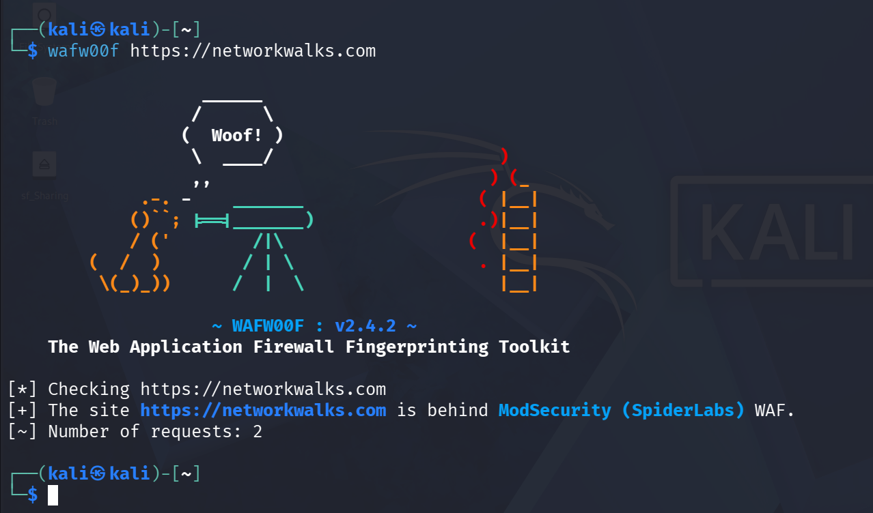

TASK NO 6: Enumerate all DNS records: name servers, mail servers, SPF, TXT and (SRV) records
DNSRecon Tool: DNSRecon is an advanced DNS enumeration tool used during the reconnaissance phase of penetration testing. Its primary purpose is to gather DNS information about a target domain, including A, AAAA, MX, NS, TXT, and SOA records. It can also perform subdomain enumeration, DNS cache snooping, and attempt DNS zone transfers (AXFR) to identify misconfigured DNS servers. This information helps security professionals map domain infrastructure, discover hidden subdomains, identify mail servers, and detect potential DNS misconfigurations.
dnsrecon -d networkwalks.com (Performs standard DNS enumeration.)
dnsrecon -d networkwalks.com -t std (Performs standard DNS record checks.)
dnsrecon -d networkwalks.com -t axfr (Attempts DNS zone transfer testing.)

Security Purpose: DNSRecon helps penetration testers discover exposed DNS information, map an organization's external attack surface, and identify potentially insecure DNS configurations. Use only on authorized targets.
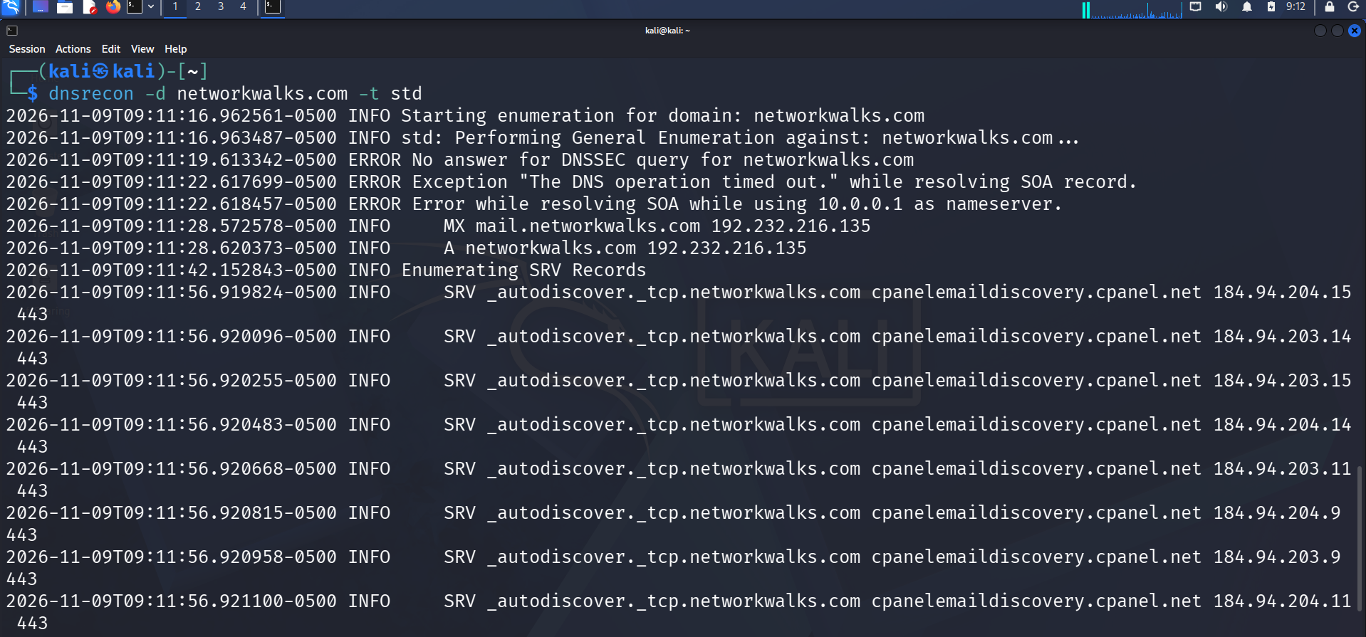
DNSRecon Scan – Key Findings for networkwalks.com:
The DNSRecon scan identifies the domain's A record pointing to IP address 192.232.216.135. Its MX record points to mail.networkwalks.com, resolving to the same IP address, indicating the mail service uses the same server IP. The scan also discovers eight SRV records associated with the _autodiscover._tcp service, pointing to cPanel email discovery infrastructure (cpanelemaildiscovery.cpanel.net) on port 443. DNSSEC queries received no answer, while SOA record resolution timed out through the local DNS server 10.0.0.1. A total of 8 DNS records were identified.
Security Observation: The findings reveal the domain's web and email infrastructure, cPanel email discovery services, and potential DNS configuration issues. However, the DNSSEC and SOA errors may be caused by DNS resolver limitations or timeouts and do not independently confirm misconfiguration.

PROJECT MODEULE-5 (ESSENTIAL)

NETWORK SCANNING WITH ZENMAP

CYBERSECURITY & ETHICAL HACKING PROJECT TASKS

TASK NO 1 Download & install Zenmap from official website on your Windows PC
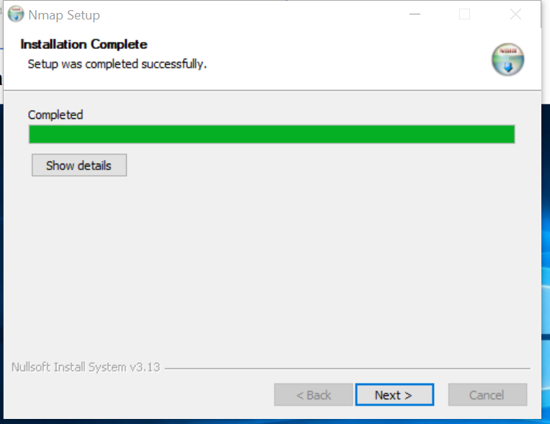

Task2 Find your local IP address & your LAN subnet
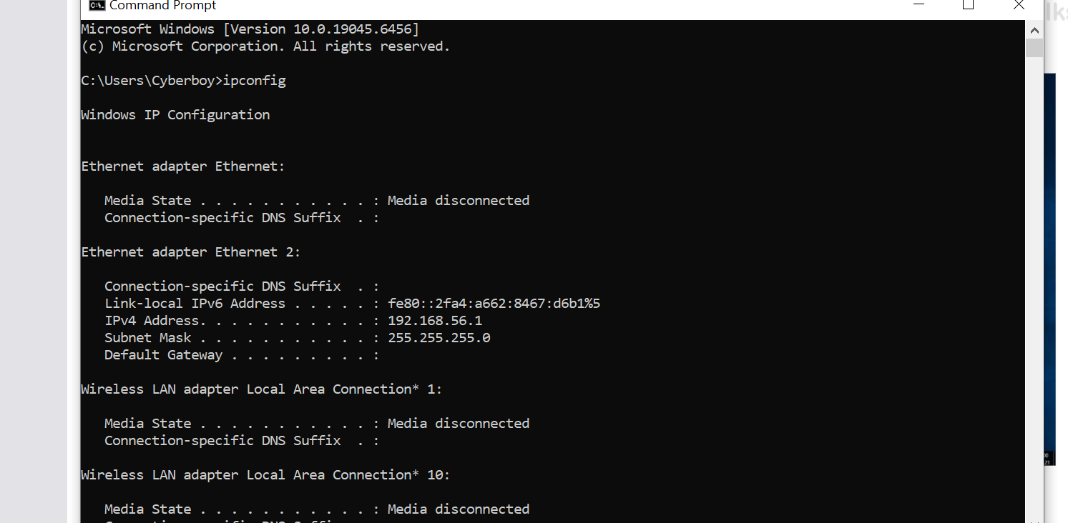

Task3 Find the list of live hosts/PC’s in your IP subnet
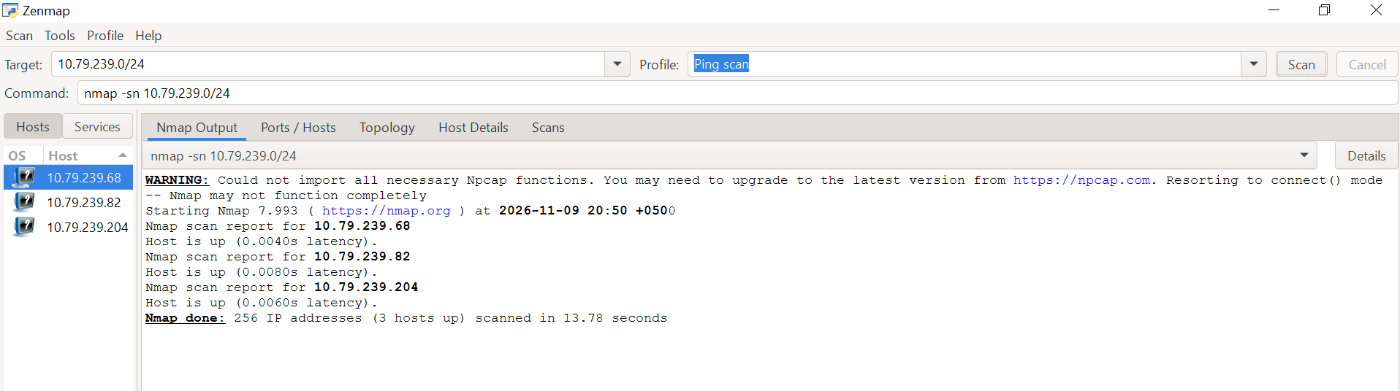

Task4 How many hosts are live in subnet?
Answer: 3 hosts are live in your subnet.
Scan summary:
- Total IP addresses scanned: 256
- Live hosts: 3
- Subnet: 10.79.239.0/24

Task5 What are the IP addresses of the live hosts?
IP Address | Device
10.79.239.68 | Network Gateway
10.79.239.82 | Windows Host
10.79.239.204 | Kali VM

Task6 What are the MAC addresses of the live hosts?
Live Host | Address | MAC Address
Gateway 10.79.239.68 0e-84-ed-fc-60-eF
Window Host 10.79.239.82 CC-3D-82-90-38-Fe
Kali VM 10.79.239.204 08:00:27:5A:87:BA

Task7 Display & save the output topology in PDF Format on your desktop
I saved output on my desktop. Here is zoomed screenshot attached for reference, please.



